## Merchant

Demo date:   
Scoping start date:

MSA Signature Date:   
Onboarding Kick Off Date:

[If Exists] Opt Out Date:  
Go Live Date:

GTM POC:   
Implementation POC:

ERP:

Tax Integration:

### 

### Key people at Merchant

### Accountant:

### CFO:

### Customer service rep who is really involved:

* Account Receivable POC
* Billing POC

### Etc.

### 

| Notes Sections [Ops International Team to Ignore] *(AE/ Implementation to fill)*   * Info on how merchant bills   + Spreadsheets related to implementation * Is there any important merchant relationship information?  1) What is the merchant temperament? 2) Is there a key POC: (i.e.: who is the buyer/decision maker?) 3) What are the Tabs features that the key POC cares about? |
| --- |

### 

### Company summary *(AE to fill)*

Summary of what company does

Goals (North star)  
*(AE/ Implementation to fill)*

What is the merchant's goal? What pain are we solving? Why are they buying Tabs?  
  
Is there an opt out clause? If so, what is the merchant looking for so they do not exercise it?

### Billing model *(AE/ Implementation to fill)*

* Are there unique things about the customer creation process for this merchant?
* Information on how merchant bills
* How contract is broken up
* One off things to know about the merchant

### Contract Processing Steps *(Implementation/Success to fill)*

1. Steps to process
   1. Minimum commitment fee as a flat fee BT
      1. Additional/overage fees as a usage BT
   2. Add a BT for waived fees
   3. Dates: Usually at the start of the production period
      1. Mentioned under payment terms
      2. Dates under term and termination

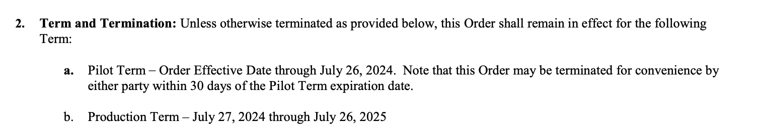

* 1. If tiered unit pricing is used with a monthly commitment, the minimum tier should reflect the commitment

1. Anything to ignore in contracts?
2. Specifics processing things the merchant has requested that may differ by contract (e.g. always back-date invoice date to final day of the month)
3. Default Service Term
   1. If None Listed, Ops Default is 1 Year
4. Default Net Payment Terms
   1. If None, Ops Default is 0
5. Default Billing Frequency
   1. If None Listed, Ops Default is Monthly
6. How do we handle taxes as a line item?
   1. If None Listed, Ops Default is every tax line item becomes a BT

### Events Processing (if necessary) *(Implementation/Success to fill)*

* Any important information on events billing

Integration Items Processing (if necessary)  
*(Implementation/Success to fill)*

* Additional Verifications for entity verification
* License Verification | One-time Setup Fee for set up fees
* What are the instructions for assigning integration items?
* Example: All Statsig integrations items should be labeled as “Sales”
* Example: All “Pinata” integration items should be labeled as “Software Subscription Bundle” unless otherwise noted by Merchant

Post Processing Communications (if necessary)  
*(Implementation/Success to fill)*

* Does the Ops Team need to notify anyone on the team re: completion of processing batches in Implementation or Active phase?
* Who needs to be notified and when?
  + Example:
    - Who: Customer Success [Azmat Aziz] needs to be notified
    - Where: Messari internal merchant channel
    - When: contracts are processed [Merchant Phase: Active]

### Customer Information *(Implementation/Success to fill)*

* Any important information on specifics customers of this merchant
  + Special memo’s certain invoices require
  + Invoice changes due to merchant/customer relationship

### Feature Requests *(AE/Implementation/Success to fill)*

* FR 1
  + What is it
  + Why it's important
  + Urgency

### Rewatch Calls *(AE/Implementation/Success to fill)*

* Rewatch by dates